We hope you're keeping warm this winter. Please enjoy this newsletter, especially if you're interested in funding - lots of information!


ISSUE 20: February 2023
In this issue:
1. Latest News
2. Upcoming Events
3. Latest Funding Opportunities

Latest News: Climate Week North East 2023
24th March - 2nd April

A number of events has been organising on the Climate Week. Pick up your brochure from your local library or community centre. Don't forget to mark your calendars and check out events on the website: climateweeknortheast.org

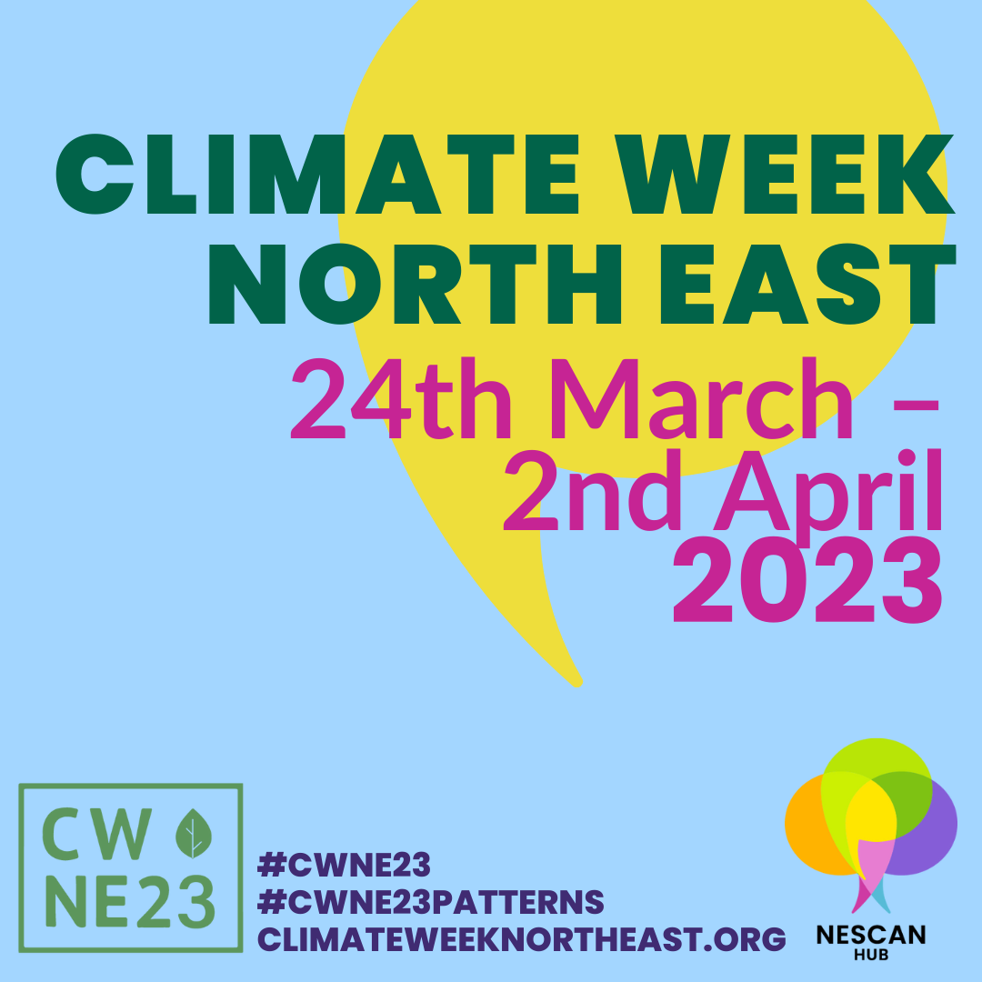

Free website hosting by SCCAN
We've had a number of queries about creating websites for community climate action groups. One option worth investigating is through the Scottish Communities Climate Action Network. Membership is free and comes with a number of benefits, including access to free website hosting, with build-in support. This facility enables you to create a “hosted” website for your group or project that sits under the sccan.scot domain. The latest WordPress software enables you to construct simple or complex page layouts starting from a template that is highly customisable with many different options. You would be able to start with a single page website; or construct a more complex site with multiple pages and navigation menus. This facility comes with free support and a starter website that you can modify as much as you please. Rachel@nescan.org


NESCAN Hub's first Community Assemblies are well underway.

  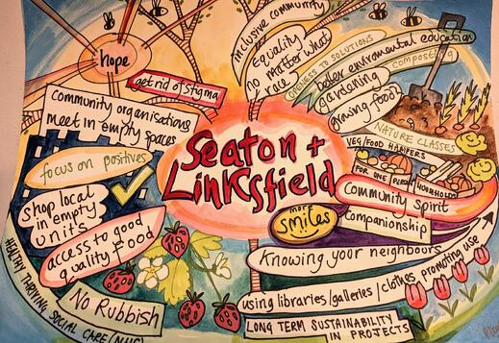
  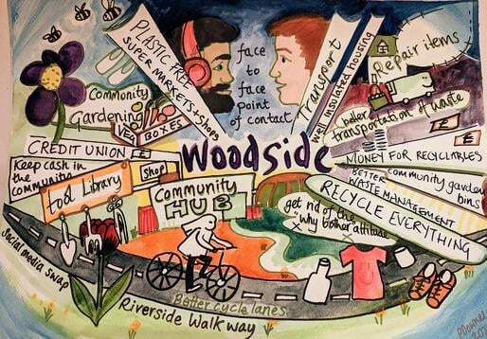
  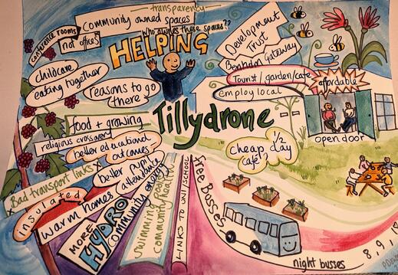
  We've gathered, we've connected, we've learned and will continue to do so.
  We have worked hard to create a supported space in which folk are able to listen well to each other, think creatively about their place and the wider world and experience a process that enables brave and supported discussion about climate change and its impacts. Folks from the areas of Tillydrone, Seaton & Linksfield and Woodside met on Wednesday evenings throughout January and February at St Machar Academy for a hot vegan meal, followed by conversations with experts in the field and those with lived experience.
  We included plenty of time to discuss and deliberate on priorities for their communities.

We set the scene by exploring how climate change is having many impacts on our area and the need to transition to net zero. We explored how communities can collaborate for a just transition and considered changes that we need to see in the areas of energy and buildings, transport, outdoor spaces, the circular economy and food. As part of the process, the Assemblies will seek feedback and input from the wider local community on the draft action plan and communities will be supported to put the actions in motion.
Feel free to get in touch if you would like to find out more. Chris Bodington christine@nescan.org.

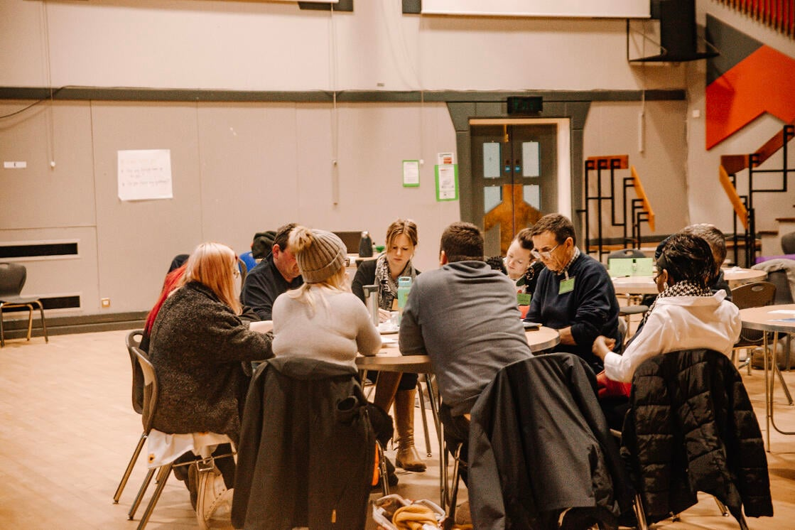



Need Help with your Fundraising?
Rachel, our Fundraising and Development Officer, is available to work with groups to explore ideas for new projects and help with funding applications. Contact at

rachel@nescan.org

  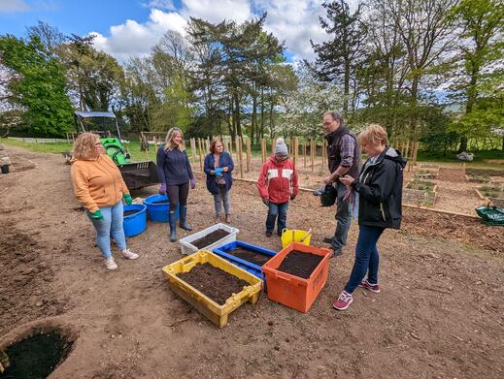
  NatureScot Funding:
  The Scottish Government and NatureScot, working in partnership with the National Lottery Heritage Fund, are launching a new £1.8m programme of support to help scale up private investment in Scotland’s natural capital. This fund supports environmental organisations, community groups, land owners and farmers for nature projects.
  Grants of up to £240,000 will be offered to organisations and partnerships to help develop a viable business case and financial model, to attract investment in projects that can restore and improve the natural environment, such as, but not limited to, woodland creation, marine enhancement and peatland restoration. Successful projects will also demonstrate the means to engage and share benefits with communities, contributing to a just transition.
  For more information please visit:
  Funding to help nature projects grow | NatureScot.
  NESCAN SEED FUNDING:
  Would you like to apply for up to £1000 to kickstart your project idea? The deadline of 28th of February (or while funds remain) is fast approaching and the funds are being allocated to eligible projects on a first come first served basis. This year we are supporting brilliant projects such as tool libraries, composting, swift boxes, first aid kits, training courses, raised beds, publicity information for projects, native seeds, shrubs, trees and pollinator-friendly spring flowers. If you have an idea for a small grant to help your community become more sustainable and biodiverse, please let us know: we might be able to help. Contact rachel@nescan.org or apply online while funds remain.
  The Community Action Fund
  The National Lottery Community Fund gives grants to organisations in the UK to improve their communities.
  The fund awarded comes from Th UK National Lottery. This funding aims to help communities to address climate change.
  - Funding size is up to £1.5 million over 2 to 5 years, with most projects between £300,000 and £500,000.
  - Development grants of £50,000 to £150,000 over 12 to 18 months.
  Application deadline: Ongoing.
  For more information please visit:
  Climate Action Fund - Nature and Climate | The National Lottery Community Fund (tnlcommunityfund.org.uk)

Unlock our Future Fund
The Vattenfall Unlock our Future Fund is now open. The fund supports projects in Aberdeen and Aberdeenshire contributing towards the following objectives:
- contribute to a climate smarter world with sustainability at its core
- invest in community facilities and activities that are fit for the future and are environmentally sustainable, especially community spaces and transport
- support creative solutions
- ensure a legacy and lasting impact, which clearly brings benefit to the local community
There are two levels of award available: small grants up to £2,000 and large grants of up to £15,000 in a single year with the possibility of up to £30,000 for projects running over three years.
There will be an online seminar for potential applicants 16:00 – 17:00 on 2nd March 2023. A recording will be available after the event.
There will also be face to face surgeries in Banchory, Huntly and Aberdeen City Centre on 15th and 16th March 2023 to help with any queries from applicants.
If you can’t make the face to face sessions, support is available from Foundation Scotland over the phone or online.

Applications close: 17 April 2023.

Details of how to book onto the online seminars and the application form and supporting information are on the web page here.

The Scottish Land Fund
This fund is supporting urban and rural communities to become more resilient and sustainable through the ownership and management of land and land assets. The fund awarded comes from The UK National Lottery.
Suitable for: Voluntary or community organisations, Public sector organisations
Funding size:£5,000 to £1,000,000.

Application deadline: Ongoing.

For more information about the Fund, please visit: Scottish Land Fund | The National Lottery Community Fund (tnlcommunityfund.org.uk)



  ACA Climate Café
  Tuesday, 28th March at 7pm (in person)
  “Active and Public Travel in the North East of Scotland”
  ACA and NESTRANS will lead a discussion on Active and Public Transport in Aberdeen with the aim of feeding into decision makers.
  Register here:
  Free Tickets, Reserve a Spot
  ACA Climate Café
  Tuesday, 7th March at 7pm (on Zoom)
  “Circular Economy”
  Speakers will be showcasing several practical examples of how circular economy can help us eliminate waste and pollution, circulate products and materials, and regenerate nature.
  Register here:
  Free Tickets, Reserve a Spot
  Sustrans
  Big Walk and Wheel is taking place 20-31 March 2023
  Register your school now for the UK’s biggest inter-school walking, wheeling, scooting and cycling to school competition. For more information, please visit:
  Sustrans Big Walk and Wheel
  There are other events organised by
  Sustrans and Mental Health Aberdeen on the Climate Week North East including:
  - Climate , Community and Active Travel
  - ‘Climate, Community and Active Travel’ webinar
  - Climate Cafe- Public Transport for NE Scotland: What do we want and how will we get there?
  SCCAN Annual Gathering 'Re-imagining the Future' in Edinburgh
  Come to the Scottish Communities Climate Action Network (SCCAN) annual gathering to celebrate achievements, share experiences &amp; ideas for 2023 - Join in to 're-imagine local democracy'
  Find out more here
  
  Want your event listed in NESCAN Newsletters?
  Please make sure to email info@nescan.org to ensure your event gets listed in the newsletters and send imagery and your username(s) if you'd like us to share on social media.
  Gardening for Wellbeing!
  Sharing ideas and support across the county
  Sunday, 26 March, 2023, 10:00 to 15:00
  Earth & Worms Community Garden, behind 107A Hayton Rd. AB24 2YT
  Part of Climate Week North East, Aberdeen & Aberdeenshire: Come along to share ideas and network with others interested in supporting people through gardening. Meet at Earth & Worms Community Garden then onto nearby indoor venue. Incl. Seed swap, garden tour, lunch, and guest speakers. For booking, please visit:
  Find out more here

Volunteers are needed!
Kemnay Energy Saving Project

If you are be interested in retro-fitting works, there is a session for you to speak to us is on Saturday 18th March 1000-1400, in Kemnay Village Hall.

All are welcome for a nosey at the equipment that is used to discover the defects that make your home hard to heat. Have a chat on how you could take simple measures to reduce heat loss and look at the more long-term changes to reduce carbon footprint.
Volunteer your home so that we can choose different build types to kick off the sharing of information.
Volunteers are needed to undergo familiarisation on how to use our equipment and undergo accredited training to survey homes. For more information about this project, please attend this drop in event on 18th March or for more information, please contact greenerkemnaytrustees@gmail.com.

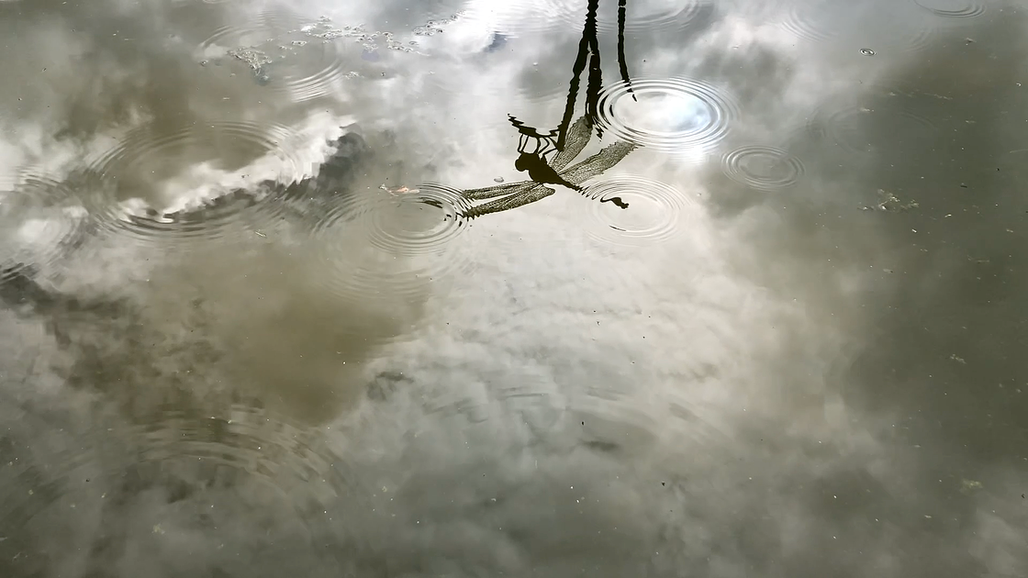
Carrie Fertig, multi-disciplinary artist working in video, performance, installation, sound, sculpture and virtual reality is running a number of free course, these course are free and include nature writing, which happens over Zoom; video, audio, art in nature which happen face to face in and around Kincardinshire; and virtual reality which happens face to face and in the headset. Health of the Sublime in the Mearns offers a deep dive into the lived experience of wellbeing in the natural world in year one and is generously supported by Creative Scotland. In year two we focus on how climate change impacts this lived experience of wellbeing in the natural world.

Details of upcoming courses:

- Nature writing/poetry is led by award winning author Janice Mackay and meets over Zoom Thursdays 2:30-4:30pm through March 30th.
- Video and Imagery meets face to face in and around (we use that term loosely) Stonehaven Thursdays 10am-12noon, through March 30th.
- Audio meets Mondays 12:30-2:30 face to face in and around Laurencekirk.
- Art in Nature meets Mondays 9:30-11:30am face to face in and around Laurencekirk, through March 27th
- Virtual Reality meets at the convenience of the participant and has special requirements, but is the most supported thread of creative tuition.


Not subscribed to our newsletter? Click here to join our mailing list! 💚
Have you received this newsletter by mistake or no longer wish to receive this newsletter? Unsubscribe using the button below.

NESCAN Hub, -, Aberdeen, -
Unsubscribe Manage preferences

Send free email today


